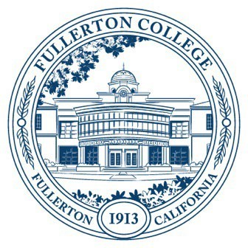

Agenda of Fullerton College

Professional Learning Committee

September 26, 2024

2:00 – 4:00 PM via Zoom

[Zoom Meeting Link](https://fullcoll-edu.zoom.us/j/85841175536?pwd=dXAPa3YWNnGrE64NHovHDGtSxbmP2L.1)

**I. Public Comments (limited to 3 minutes per person), 10 minutes**

**II. Standing Reports (Informational, 10 minutes)**

A. None on 9/26 Agenda

**II. New Business**

A. Fall 2024 Funding Proposals (Action, 20 minutes)

* Travel requests
  + Nicole Rossi – May 26, 2025
  + Angela Buechner – May 26, 2025
  + Monica Hagmaier– May 26, 2025
  + Liliana Ramsey – June 8, 2025
  + Kyra Kirkwood – October 25, 2024
  + Amber Tsung Ju Kuo –November 11, 2024
  + Allison Rodgers-Griffen –October 27, 2024
  + Bianca Glanden – February 12, 2025
  + Cristina Arellano – October 9, 2025