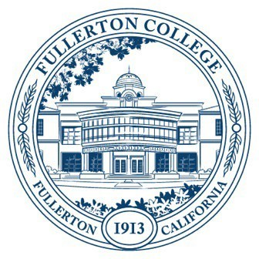

Agenda of Fullerton College

Professional Learning Committee

December 12, 2024

2:00 – 4:00 PM

In-Person – Building 800, Room 822

1. **Approval of minutes: November 14, 2024**
2. **Public Comments (limited to 3 minutes per person, 10 minutes)**
3. **Standing Reports (Informational, 10 minutes)**
   1. Cynthia Guardado, Professional Learning Coordinator
      1. **Flex Day/Feedback** 
         1. Recap on the day's events and positive feedback.
         2. Still in progress:
            1. Collecting feedback via Microsoft Forms
            2. Collecting Attendance Rosters
         3. **Adjunct Academy**
            1. Recap on the day's events and positive feedback.
            2. 34 Adjunct faculty Participated
            3. Planning a Fall Adjunct Academy
      2. **Race-Conscious Certificate**
         1. Manager cohort will begin this Spring, Faculty cohorts will be scheduled in Summer, and Classified Professional cohorts will be scheduled in Fall.
      3. **Black History Month/Asian American and Pacific Islander Month** 
         1. Books have been purchased for a free book pop-up by culturally relevant authors at Black History Month events.
         2. Collaborations are ongoing with APIDA.
      4. **Hiring Training Open to the Public**
   2. Darnell Kemp, Distance Education
   3. Dani Willoughby, Dean of LLRISPD
4. **Old Business**
   1. **Budget Update (Informational, 10 minutes)**
      1. Administrative Assistant, Jason Lopez, will provide a quick budget recap to the committee on the Staff Development General Budget.
5. **New Business**
   1. **Spring 2025 Funding Proposals (Action, 20 minutes)**
      1. Travel requests
         1. Alejandra Ceja (Dissemination Plan)
            1. Submitted last fall term.
         2. Monica Lee (Perkins Funding)
   2. **Need Based Prepayment Prior to Travel Application (Jason)**
      1. Overview and limitations of prepayment.
      2. Review form for feedback: <https://forms.office.com/r/vpcjNUaDd0>
   3. **Professional Learning Campus Survey**
      1. Review previous campus surveys regarding professional learning.
      2. Discuss best time and approach to administer the survey.