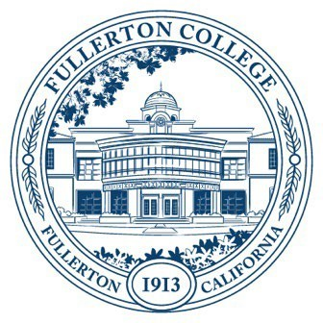

Agenda of Fullerton College

Professional Learning Committee

February 27, 2025

2:00 – 4:00 PM

In-Person – Building 800, Room 822

1. **Approval of minutes: February 13, 2025**
2. **Public Comments (limited to 3 minutes per person, 10 minutes)**
3. **Standing Reports (Informational, 10 minutes)**
   1. Cynthia Guardado, Professional Learning Coordinator
   2. Darnell Kemp, Distance Education
   3. Dani Wilson, Dean of LLRISPS
4. **Old Business**
5. **New Business**
   1. **Spring 2025 Funding Proposals (Action, 5 minutes)**
      1. Travel/Funding requests
         1. None on 2/27/25 Agenda
   2. **Mission Statement**
      1. Revision of the following mission statement: The Professional Learning Committee is devoted to supporting the professional learning needed for Fullerton College educators—Faculty (full-time and adjunct), Classified Professionals and Managers–to improve student success. Staff Development support should contribute to this improvement not only in individual classrooms and student support areas, but across the campus as a whole. Staff Development believes this will best be achieved by encouraging shared learning and a culture of collaboration in order to become a truly learning-focused institution.
   3. **Staff Development Surveys**
      1. Whole Campus Staff Dev Survey: Review previous Staff Development survey questions for the campus and make suggestions for revision and adding new questions.
         1. How satisfied or dissatisfied are you with the Staff Development Office's COLLEGIALITY?
         2. How satisfied or dissatisfied are you with the Staff Development Office's TIMELINESS?
         3. How satisfied or dissatisfied are you with the Staff Development Office's HELPFULNESS?
         4. How satisfied or dissatisfied are you with the Staff Development Office's EFFICIENCY?
         5. How satisfied or dissatisfied are you with the Staff Development Office's COMMITMENT TO DIVERSITY, EQUITY, INCLUSION AND ANTI-RACISM?
         6. How satisfied or dissatisfied are you with the Staff Development Office's COMMITMENT TO STUDENT SUCCESS?
         7. What is the Staff Development Office doing particularly well? (Short Response)
         8. What could the Staff Development Office do to improve? (Short Response)
         9. Please include any other comments you have regarding your experiences with the Staff Development Office. (Short Response)
      2. Classified Professional Inquiry Survey: General Survey to better serve classified.
         1. <https://forms.office.com/r/eVH4TLs2xC>