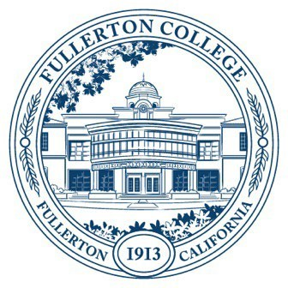

Agenda of Fullerton College

Professional Learning Committee

March 13, 2025

2:00 – 4:00 PM

In-Person – Building 800, Room 822

1. **APPROVAL OF MINUTES: FEBRUARY 27, 2025**
2. **PUBLIC COMMENTS (LIMITED TO 3 MINUTES PER PERSON, 10 MINUTES)**
3. **STANDING REPORTS (INFORMATIONAL, 10 MINUTES)**
   1. Cynthia Guardado, Professional Learning Coordinator
   2. Darnell Kemp, Distance Education
   3. Dani Wilson, Dean of LLRISPS
4. **OLD BUSINESS**
   1. **Staff Development Name Change (Action)**
   2. **Mission Statement (Informational)**
      1. Review of revised draft. (1st Read)
   3. **Staff Development Survey (Informational)**
      1. Review of survey draft. (1st Read)
5. **NEW BUSINESS**
   1. **Spring 2025 Funding Proposals (Action, 5 minutes)**
      1. Travel/Funding requests
         1. Jessica Langlois (Perkins Travel Funding)
      2. Online Learning Center (request via Distance Ed)
   2. **Speaker Invitation (Informational)**
      1. Val Macias will discuss ER Funds for inviting a speaker to Fullerton College. This would be a collaborative effort between Staff Development for employee professional learning.