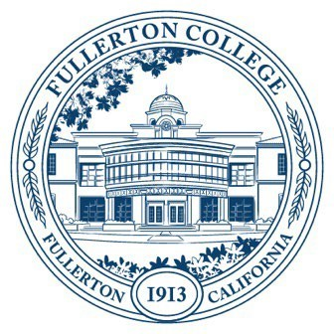

Agenda of Fullerton College

Professional Learning Committee

April 10th, 2025

2:00 – 4:00 PM

In-Person – Building 800, Room 822

1. **APPROVAL OF MINUTES: MARCH 13, 2025**
2. **PUBLIC COMMENTS (LIMITED TO 3 MINUTES PER PERSON, 10 MINUTES)**
3. **STANDING REPORTS (INFORMATIONAL, 10 MINUTES)**
   1. Cynthia Guardado, Professional Learning Coordinator
   2. Darnell Kemp, Distance Education
   3. Dani Wilson, Dean of LLRISPS
   4. Jason Lopez, PLC Admin II
4. **OLD BUSINESS**
   1. **Staff Development Survey (Informational)**
      1. Review of survey draft. (1st Read)
5. **NEW BUSINESS**
   1. **Spring 2025 Funding Proposals (Action, 5 minutes)**
      1. Humanities Professional Learning Day
      2. Library Professional Learning Day
      3. Travel Funding
         1. PAR - Kristin Mihaylovich
   2. **Strategic Plan Objective Feedback (Informational)** 
      1. Goal 1 - Objective 5: Deepen engagement in DEIA-focused professional development for full-time and part-time faculty and staff
      2. **Revisions**
         1. Deepen engagement in DEIA via multi-session professional learning workshops in which faculty and staff interrogate existing practices to ensure equitable outcomes
         2. Deepen engagement in DEIA via multi-session professional learning workshops in which faculty and staff interrogate existing practices
         3. Enhance equitable outcomes via multi-session DEIA professional learning workshops for faculty and staff
   3. **Fall Flex 2025**
      1. Ideas for Flex Workshops
      2. Ideas for Keynote (if Cypress College gives us Flex)