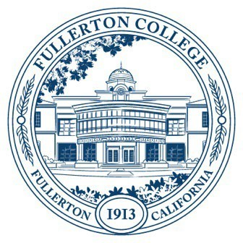

Agenda of Fullerton College

Professional Learning Committee

April 24, 2025

2:00 – 4:00 PM

In-Person – Building 800, Room 822

1. **APPROVAL OF MINUTES: April 10, 2025**
2. **PUBLIC COMMENTS (LIMITED TO 3 MINUTES PER PERSON, 10 MINUTES)**
3. **STANDING REPORTS (INFORMATIONAL, 10 MINUTES)**
   1. Cynthia Guardado, Professional Learning Coordinator
   2. Darnell Kemp, Distance Education
   3. Dani Wilson, Dean of LLRISPS
   4. Jason Lopez, PLC Admin II
4. **OLD BUSINESS**
   1. **Staff Development Survey (Informational)**
      1. Review of survey draft. (1st Read)
   2. **Mission and Purpose Revision (Action)**
5. **NEW BUSINESS**
   1. **Spring 2025 Funding Proposals (Action, 5 minutes)**
      1. Ethnic Studies Adjunct Professional Learning Day
      2. Travel Funding
         1. PAR – Scott Lee
         2. PAR – Distance Education Online Teaching Conference (10 Faculty)
   2. **Travel Funding for 2025-2026 (1st Discussion, 15 minutes)**
      1. This discussion will be centered on the 25/26 budget for PLC. Things to note:
         1. Currently our budget is $65,000
         2. Starting 25/26 we will be providing a $2500 (max) reimbursement.
         3. 24/25 we ran out of money by the end of the Fall semester.
         4. Will we still continue to evaluate travel the same way? How will we make the best use of our travel budget?
   3. **Mission and Purpose (Action, 10 minutes)**
      1. After presenting at Faculty Senate on 4/17 they had questions and feedback regarding the mission. The main concern was consistency across the mission and purpose in language of how the committee and the office work together. Primarily showing that the PLC committee guides the office not the other way around.
         1. **Mission:** The Professional Learning Committee, a dual-reporting committee, is devoted to supporting the learning of Fullerton College employees—Faculty (full-time and part-time), Classified Professionals, and Managers–by developing professional learning that aligns with Fullerton College’s Mission and Goals. The Professional Learning Committee serves the Fullerton College by developing professional learning that builds a community of collegiate collaboration which interrogates existing practices—in the classroom and the campus as a whole—with a mission to improve excellence in teaching and learning, student support, technological advancement, institutional effectiveness, and the development of model academic and professional programs.
         2. **Purpose:** In order to further these goals, the Professional Learning Committee determines priorities, and policies, for the Office of Professional Learning based on communication with constituent groups; develops campus-wide professional learning activities and workshops to meet identified needs; makes budgetary decisions for professional learning that emphasizes diversity, equity, inclusion, and accessibility and aligns with the college’s Student Equity and Achievement Plan.