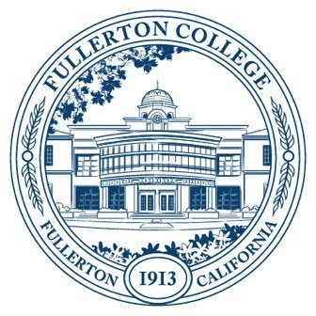
Agenda of Fullerton College
Professional Learning Committee
October 9, 2025
2:00 – 4:00 PM
In-Person – Building 800, Room 822

Members Present:
Members Not Present:

- APPROVAL OF MINUTES: September 25, 2025
- PUBLIC COMMENTS (LIMITED TO 3 MINUTES PER PERSON, 10 MINUTES)
- STANDING REPORTS (INFORMATIONAL, 10 MINUTES)
  - Cynthia Guardado, Professional Learning Coordinator.
  - Darnell Kemp, Distance Education
  - Dani Wilson, Dean of LLRISPS
  - Jason Lopez, PLC Admin II
- OLD BUSINESS
  - Revision of AP 7400, Employee Travel and Conference Attendance (Discussion, Second Read —30 minutes)
  - Classified Professional Survey (Discussion – 30 minutes)
- NEW BUSINESS
  - Fall 2025 – Spring 2026 Funding Proposals (Action, 10 minutes)
    - General Funding Proposals
      - None on October 9th, 2025, agenda.
    - Travel Funding
      - Sarah Queneau
      - Sylvia Pimentel
        - International Travel: 11/22
      - Leonard Cho
      - Laura Lazarus
      - Deidre Hughes
      - Maria Cadena
      - Lyman Medeiros

