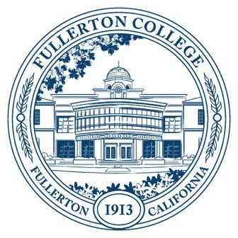
Agenda of Fullerton College
Professional Learning Committee
September 11, 2025
2:00 – 4:00 PM
In-Person – Building 800, Room 822
- APPROVAL OF MINUTES: May 22, 2025
- PUBLIC COMMENTS (LIMITED TO 3 MINUTES PER PERSON, 10 MINUTES)
- STANDING REPORTS (INFORMATIONAL, 10 MINUTES)
  - Cynthia Guardado, Professional Learning Coordinator
  - Darnell Kemp, Distance Education
  - Dani Wilson, Dean of LLRISPS
  - Jason Lopez, PLC Admin II
- OLD BUSINESS
  - Dual Enrollment Training
    - The Dual Enrollment in-person training in August was cancelled due to low enrollment. We are going to reallocate the funds to build an asynchronous training for Dual Enrollment faculty instead.
  - Classified Professionals RCC
    - Update: The call for sign-ups for the CP-RCC went out. Managers have been asked by Dr. Olivo to help coordinate schedules for Classified Professionals in case their RCC work can be completed within their 40hr work week. Those who complete the work outside of their regularly scheduled hours will be paid in overtime from the PLO budget/ER Funds.
  - AI Three Part Training Series
    - Toni Nielson is currently working on revising and developing a three-part AI training series. These sessions will include AI literacy (what is the impact of AI and best practices) and practical ways to use AI.
  - CoRE Winter Cohort
    - The last CoRE cohort that will be funded by the grant is going to be scheduled for Winter 2026. This cohort will be smaller due to limited funds.
    - Discussion on sustaining CoRE through PLO will be on our next agenda.
- NEW BUSINESS
  - Fall 2025 – Spring 2026 Funding Proposals (Action, 10 minutes)
    - Discussion/Question: Eligibility of Perkins Funding Reimbursement for CTE Faculty Completing Certificates.
    - General Funding Proposals
      - None on September 11th, 2025, agenda.
    - Travel Funding
      - Michael Gieck
      - Erin Joy Araneta
      - Bridget Kominek
      - Karina Corona
  - Flex Proposals (Discussion – 15 minutes)
    - What do we think about moving the Flex Day call for proposals to early in the semester? This would allow us to approve Flex Day proposals earlier in the semester (versus the end) and to assess any gaps in our program.
    - Spring 2026 proposal applications could be open from Monday, September 15 with the deadline set before the final PLC meeting on Thursday, December 11.
      - A reminder could be sent at the end of October.
  - Proposed PLO/PLC Goal for the Year (Discussion – 15 minutes)
    - First discussion on creating a partnership with OIE for course success data to be regularly accessed by all faculty at the end of each academic year.
  - Potential PD Ideas for the Year (Discussion – 15 minutes)
    - Grant writing workshops.
    - Mental Health workshops.
    - Event centering students with disabilities. Screening of the film “unseen” and talk with director and protagonist.
    - Book Clubs for STEM

