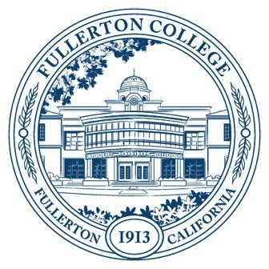
Agenda of Fullerton College
Professional Learning Committee
December 11, 2025
2:00 – 4:00 PM
In-Person – Building 800, Room 822

- APPROVAL OF MINUTES: November 13, 2025
- PUBLIC COMMENTS (LIMITED TO 3 MINUTES PER PERSON, 10 MINUTES)
- STANDING REPORTS (INFORMATIONAL, 10 MINUTES)
  - Cynthia Guardado, Professional Learning Coordinator.
  - Darnell Kemp, Distance Education
  - Dani Wilson, Dean of LLRISPS
  - PLC Admin II
- OLD BUSINESS
  - End-of-Semester Disaggregated Success Data Formal Recommendation (First Read, 10 minutes)
- NEW BUSINESS
  - Fall 2025 – Spring 2026 Funding Proposals (Action, 10 minutes)
    - General Funding Proposals – No proposals
    - Travel Funding
      - Jeremy Siskind
      - Monica Lee
      - Nicole Winborne
      - Timothy Ream
      - Anya Shyrokova
      - Joel Salcedo

