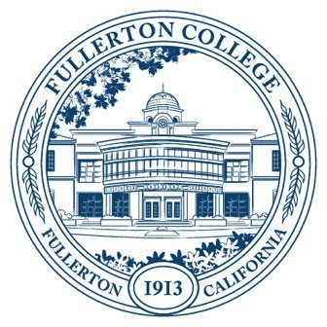
Agenda of Fullerton College
Professional Learning Committee
February 12, 2026
2:00 – 4:00 PM
In-Person – Building 800, Room 822

Members Present: Cynthia Guardado, Dani Wilson, Crystal Nava, Angela Henderson, Amber Tsung Ju Kuo, Diana Luu, Martie Smith, Gita Nilkanth, Chynna Barnett, Carina Valencia, Darnell Kemp, David Jacobsen, Naveen Kanal
Members Not Present:

- APPROVAL OF MINUTES: December 11, 2025
- PUBLIC COMMENTS (LIMITED TO 3 MINUTES PER PERSON, 10 MINUTES)
- STANDING REPORTS (INFORMATIONAL, 10 MINUTES)
  - Cynthia Guardado, Professional Learning Coordinator
    - Update on BP/AP 7400 Workgroup
    - Teaching and Learning Certificate AI series is officially scheduled.
    - Speaker Series save the dates.
    - Hiring Training (open to the public) 2/21
    - Update on HR Compliance training vote via Faculty Senate. The motion that was voted on was the following: Human Resources Compliance Trainings will not qualify for Flex day activities unless approved by the Professional Learning Committee.
  - Darnell Kemp, Distance Education
  - Dani Wilson, Dean of LLRISPS
  - Crystal Nava, PLC Admin II
    - Budget Report
- OLD BUSINESS
  - End-of-Semester Disaggregated Success Data Formal Recommendation (Action, 10 minutes)
- NEW BUSINESS
  - Fall 2026 Flex Planning
    - How do we want to align our Fall Flex with the SEA Plan and the Fullerton College Strategic Plan?
      - Meeting both faculty and student needs.
    - How will be inclusive of Classified Professionals professional development this semester?
    - The FC Faculty Senate recommends college president Dr. Cynthia Olivo use available and appropriate resources and collaborate with the Professional Learning Office to provide rapid response training to prepare for immigration enforcement activities on or near the campus. The goal is to ensure faculty and staff are aware of current protocols and AP 3415: Immigration Enforcement (Discussion)
    - Travel Funding
      - Jessica Langlois (Perkins)

