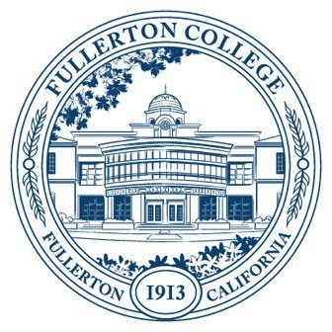
Agenda of Fullerton College
Professional Learning Committee
March 26, 2026
2:00 – 4:00 PM
In-Person – Building 800, Room 822

Members Present: Cynthia Guardado, Dani Wilson, Crystal Nava,
Members Not Present:

- APPROVAL OF MINUTES: March 12, 2026
- PUBLIC COMMENTS (LIMITED TO 3 MINUTES PER PERSON, 10 MINUTES)
- STANDING REPORTS (INFORMATIONAL, 10 MINUTES)
  - Cynthia Guardado, Professional Learning Coordinator
  - Darnell Kemp, Distance Education
  - Dani Wilson, Dean of LLRISPS
  - Crystal Nava, PLC Admin II
- OLD BUSINESS
  - Revision of AP 7400, Employee Travel and Conference Attendance
- NEW BUSINESS
  - General Funding Proposals
    - Jeffrey Samano – Adjunct Humanities Professional Learning Day

