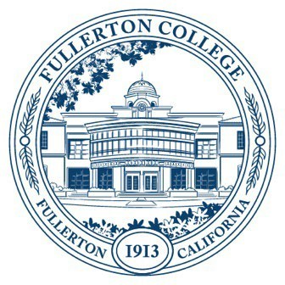
Agenda of Fullerton College
Professional Learning Committee
Meeting: April 23, 2026
2:00 – 4:00 PM
In-Person – Building 800, Room 822

Members Present: Cynthia Guardado, Dani Wilson, Crystal Nava, Martie Smith, Chynna Barnett, Carina Valencia, Darnell Kemp, David Jacobsen, Naveen Kanal, Gita Nilkanth, Angela Henderson, Amber Tsung Ju Kuo, Diana Luu
Members Not Present:

- APPROVAL OF MINUTES: March 26, 2026
- PUBLIC COMMENTS (LIMITED TO 3 MINUTES PER PERSON, 10 MINUTES)
- STANDING REPORTS (INFORMATIONAL, 10 MINUTES)
  - Cynthia Guardado, Professional Learning Coordinator
  - Darnell Kemp, Distance Education
  - Dani Wilson, Dean of LLRISPS
  - Crystal Nava, PLC Admin II
- OLD BUSINESS
  - Keynote for Fall Flex
    - Recap of Meeting with Ebony Omotola McGee, PhD
- NEW BUSINESS
  - Travel
    - Amy Shrack
  - Flex Day Proposals
    - Jodi Balma (Department)
    - Karin Pavelek (Department)
    - Meg O’Rourke (District Wide)
    - Kristy Richardson (Department)
    - Ariel Gentalen (District Wide)
  - Revision of PAR Guidelines (First Read)

