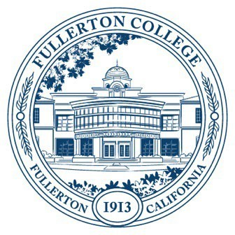
Agenda of Fullerton College
Professional Learning Committee
Meeting: April 23, 2026
2:00 – 4:00 PM
In-Person – Building 800, Room 822

Members Present: Cynthia Guardado, Dani Wilson, Crystal Nava, Martie Smith, Chynna Barnett, Carina Valencia, Darnell Kemp, David Jacobsen, Naveen Kanal, Gita Nilkanth, Angela Henderson, Amber Tsung Ju Kuo, Diana Luu
Members Not Present:

- APPROVAL OF MINUTES: April 23rd, 2026
- PUBLIC COMMENTS (LIMITED TO 3 MINUTES PER PERSON, 10 MINUTES)
- STANDING REPORTS (INFORMATIONAL, 10 MINUTES)
  - Cynthia Guardado, Professional Learning Coordinator
  - Darnell Kemp, Distance Education
  - Dani Wilson, Dean of LLRISPS
  - Crystal Nava, PLC Admin II
- OLD BUSINESS
- NEW BUSINESS
  - Travel
    - Scott Lee (traveled in 25/26)
    - Sara Rokni
    - Michelle Ramirez
    - Martha Smith
    - Jaspreet Ghotra
    - Yvonne Salazar
    - Tricia Gonzalez
    - Charlotte Jimmons
    - David Lopez
    - Wendy Perez
  - Flex Day Proposal
    - Dana Clahane (Department)
    - Andrew Clifton (Department)
    - Julio Reyes (District Wide)
    - Laura Loney (Department)
    - Roman De Jesus (District Wide)
    - Porsha Boyd (Fullerton)
    - Peter Windman (Department)
    - Gary Graves (District Wide)
    - Victor Meza (District Wide)
    - Anastasia Nagel (Department)
    - Michael Mueller (Department)
    - Greg Ryan (Fullerton)
    - Toni Nielson (District Wide)
    - Amber Gonzalez (Department)
    - George Bonnand (Fullerton)
    - Michael Mangan (District Wide)
    - Tamara Trujillo (Department)
    - Kim Vandervort (District Wide)
  - PLO Funding
    - Adjunct Professional Learning Day Philosophy (Martha Smith and Patrick Ryan)
  - Revision of PAR Guidelines (Second Read)
  - Spring 2027 Flex
    - Split from Cypress?
    - In-person?

