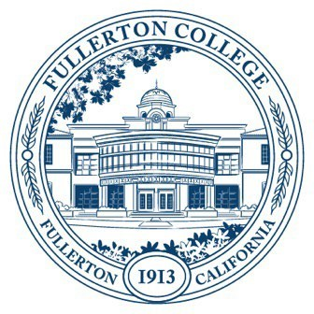

Meeting Minutes of Fullerton College
Professional Learning Committee
Meeting: May 28th, 2026
2:00 – 4:00 PM
In-Person – Building 800, Room 822

Members Present: Cynthia Guardado, Martie Smith, Carina Valencia, David Jacobsen, Naveen Kanal, Gitanjali Nilkanth, Amber Tsung Ju Kuo
Members Not Present: Dani Wilson, Chynna Barnett, Darnell Kemp, Angela Henderson, Leticia Ramirez

- APPROVAL OF MINUTES
  - May 14th, 2026 - Approved.
- PUBLIC COMMENTS (LIMITED TO 3 MINUTES PER PERSON, 10 MINUTES)
  - No public comments
- STANDING REPORTS (INFORMATIONAL, 10 MINUTES)
  - Cynthia Guardado, Professional Learning Coordinator
    - Spring 2027 will continue to be a joint program with Cypress.
    - Starting Fall 2027 and Spring 2028, Fullerton will have its own program at which point returning to in-person modality should be considered.
  - Darnell Kemp, Distance Education
    - No updates.
  - Dani Wilson, Dean of LLRISPS
    - No updates.
- OLD BUSINESS
  - Travel
    - Scott Lee - Approved
    - Tamara Trujillo - Approved
- NEW BUSINESS
  - Adjunct Professional Learning Day
    - Ryan Flores, Ceramics - Approved
    - Ziza Delgado, Ethnic Studies - Approved
  - Flex Day Proposals
    - Ryan Flores, Art Department
  - Teaching and Learning Certificate
    - Guided Pathways, TLC – Approved
      - Motion to approve moved by Martha, seconded by Gitanjali. Motion carried.
  - Revision of PAR Guidelines (Second Read)

